PLEASE SUPPORT SIS GALA WITH SCRIP!

Our annual auction is fast approaching and we are looking for your help to obtain gift cards for our very popular Gift Card Grab for the night of the auction. We will also use gift card donations to purchase items we need for the auction. Participation is swift and easy!

Keep in mind that any gift cards you donate to the auction earn PEP hours. As a reminder, a $25.00 donation equals one PEP hour, $50.00 donations equal two PEP hours, $75.00 equals three PEP hours and a donation of $100.00 equals four PEP hours.

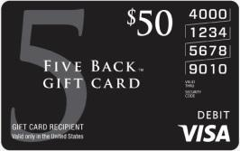

Family Name: ______________________________ Date: _______________ Contact Phone:_______________________________Check #:______________

SCRIP NEEDED | QUANTITY | QUANTITY | TOTAL
Amazon | ______X $25 | ______X $100
Disney | ______X $25 | ______X $100
Target | ______X $25 | ______ X $100
VISA | ______X $50 | ______ X $100
Safeway | ______X $25 | ______ X $100

Please write a separate check for this order form. Please make your check payable to: SI Scrip and staple check to this form. Order Total: __________

